Choices

Running Ruby
Just like the other topics, we will be running our Ruby here

http://repl.it/languages/Ruby.

We’ll be using some of the stuff we learnt about variables, and a lot of the stuff we learnt about True and False, so unless you have a really, really good memory, it’s a good idea to keep those bits of paper handy.

Choices
How many choices have you made so far today? You decided when to get out of bed (or maybe your mum decided!), what clothes you put on, what to eat, you even decided to learn some Ruby. When you make a choice it always starts with a question – Do I have to go to school today? What’s the weather like? What cereal do I fancy? Shall I do some fun Ruby coding? In Ruby choices also start with a question. Let’s see how it works.

You are the only cool person in the world!
I was 10 when I started coding. Here is one of the first programs I wrote. Type it in and run it.

puts "What is your name?"
name = gets.chomp
if name == "Spencer"
puts "You are really cool"
else
puts "You are not cool at all"
end

My name is Spencer you see, so when I ran the program and typed in my name it would tell me I was really cool, but everyone else who ran it wasn’t cool at all. The question it asked was your name, and the choice is whether it tells you you’re cool or not. Change it to be your name, then run the program and make sure it thinks you’re cool. Ask a tutor to type their name, the computer won’t think they’re cool, unless they happen to have the same name as you.
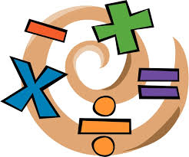

Challenge – Write a maths quiz
Write a program that asks the question

What is 7 * 8?

If they get the answer right, your program should say

Correct!

If they get it wrong your program should say

Wrong!

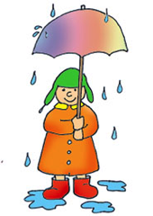
Does your program work? If you get stuck, look back at the Variables topic. If you’re still stuck, ask a tutor to give you a hint.

True or False (again!)
Do you remember this program from the True or False topic?

puts "Is it raining (yes or no)?"
raining = gets.chomp
puts "Is it hot (yes or no)?"
hot = gets.chomp
puts "You should wear a T shirt is"
puts hot == "yes" and raining == "no"

Type this in again and run it to remind yourself what it does. Now change it slightly…

puts "Is it raining (yes or no)?"
raining = gets.chomp
puts "Is it hot (yes or no)?"
hot = gets.chomp
if hot == "yes" and raining == "no"
puts "You should wear a T shirt"
end

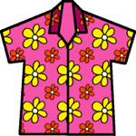
Now run it. If it is hot and not raining, it will say

You should wear a T shirt

Otherwise it will say nothing at all.

You see, True or False is about questions, and asking questions allows us to make choices. In Ruby, to make a choice you write if, then a True or False question, then the thing you will do if the answer is True. Oh, and then the end. Don’t forget the end.

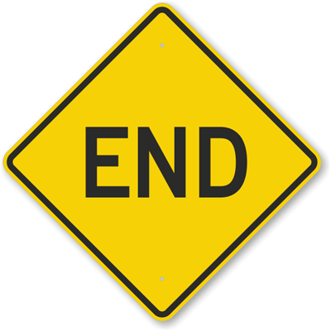
Don’t forget the End!
One of the mistakes that everyone makes, even people like me who have been coding for years and years, is missing the end off. If you miss the end Ruby will show you a scary error message. Try it now. Remove the end from your program, run it and look at the scary error message. Memorise it. You will make this mistake many times and you will see this error message every time you do. You will see it, know what it means and know how to fix it.

Two important things
Now I will tell you the most important thing to learn in this whole topic. Don’t skip this bit!

The stuff after an IF is just a True or False thing. If the answer is True, it does what it says between the IF and the END (or the ELSE if there is one).

Now I will tell you the other really important thing to learn in this topic. Don’t skip this bit either!

If the stuff after the IF is False and there is an ELSE, it does what it says between the ELSE and the END. If there is no ELSE, it does nothing at all.

Let’s prove that second bit now. Add a couple more lines to your program…

puts "Is it raining (yes or no)?"
raining = gets.chomp
puts "Is it hot (yes or no)?"
hot = gets.chomp
if hot == "yes" and raining == "no"
puts "You should wear a T shirt"
else
puts "You should wear a coat"
end
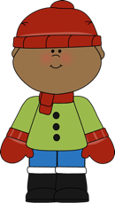
Now run it and tell the computer it is hot and raining. It should tell you to wear your coat. The computer doesn’t want you to get wet.

Do you see how this works? If you tell the computer it is hot and raining, the bit after the if is False.

hot == "yes" and raining == "no"

It is hot, that bit is True, but it is also raining, so raining == “no” is False, which makes the whole thing False. So Ruby jumps to the bit of code after the else and tells you to wear a coat.

If this is confusing, have a look back to the True or False topic, the bit about how and works.

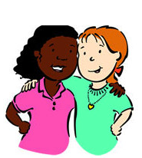
Challenge – Are you younger than your best friend?
Remember we did this challenge in the True or False topic? You had to write a program to ask the ages of you and your best friend, then tell you if you were younger than them. When you ran your program you saw something like this.

How old are you?
9
How old is your best friend?
10
You are younger than your best friend is
true

Well, now I want you to do the challenge again, but this time use if. If you are younger the program should print something like this…

How old are you?
9
How old is your best friend?
10
You are younger than your best friend

Does it work?

If you are older than your best friend you would like your program to say something like this…
How old are you?
9
How old is your best friend?
8
You are older than your best friend

And if you and your best friend are the same age you would like your program to say this…

You and your best friend are the same age

But how do we make our program do all that? This isn’t a simple if else because there are three different things we might want our program to say. Well, that’s what we are going to learn about next.

Three choices

If and else are fine so long as you have only two choices to make, like wearing a T shirt or a coat depending on the weather. When you have more than two choices, you need a Ruby elsif. What on earth is elsif? It’s Ruby shorthand for “else if”. Let’s see it in action.
Remember my coolness program? Well, once I learnt about elsif I made it a bit cleverer. This is what I did…

puts "What is your name?"
name = gets.chomp
if name == "Spencer"
puts "You are really cool"
elsif name == "Mitchell"
puts "You are a complete idiot!"
else
puts "You are not cool at all"
end

Can you see how this works? Mitchell is my brother’s name. When he ran the program it told him he was an idiot, which he didn’t find very funny.

Challenge – Finish the last challenge
Knowing about elsif means you can finish off the last challenge, which tells you if you are older, younger or the same age as you best friend. Have a go. Run it a few times and put in different ages to make sure it all works.

Challenge – Nicknames
Sometimes my brother calls himself Mitch, for short. I want my program to call him an idiot whether he types in his full name or his nickname. You can do it by changing just one line. Can you do it?

Hint – You need to use or. Look at the Questions topic if you don’t remember how or works.

Multiple choices
With elsif you are not limited the three choices, you can have as many as you like. How does all this work? Well, you always start with an if, then you have as many elsifs as you like, then you might have an else (but you don’t have to), then after all that comes the end.

Let’s try it out. Can you guess what this code will do?

puts "What colour is the sky?"
colour = gets.chomp
if colour == "blue"
puts "It must be sunny"
elsif colour == "black"
puts "It must be night time"
elsif colour == "grey"
puts "It might rain"
end

I’ve put in three colours for the sky – blue, black and grey. Can you think what other colours the sky might be?

Challenge – Red sky at night
Sometimes, not often, but sometimes the sky will go red when the sun is setting. Make the program check for red skies. If the sky is red your program should say

It must be a sunset

Challenge – Crazy sky colours
What happens if you run the program and type in some other colour, like pink? Try it. The program doesn’t print anything. It doesn’t print anything because there is no else in your code. In Ruby, else means that if none of the if or elsifs are True, run the code under the else.

Change your program so when you type in any colour other than blue, black, grey or red it says

What planet are you living on?

Bonus Challenge – Crazy sky colours II
Do you remember how to print out variables? Check the Variable Topic sheets if you can’t. Then make your program print the name of the crazy colour, so if they type in “pink” it should say

pink! What planet are you living on?

Third important thing
So now we know about elsif, I can tell you the third really important thing to remember from this topic.

Ruby moves down the IFs and ELSIFs looking for the first thing that is True so it can run the code underneath it. If nothing is True and there is an ELSE, it runs the code underneath that.
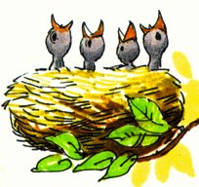

Nesting
Isn’t that what birds do? Well, yes, but it also has a meaning in Ruby. It means putting ifs inside other ifs. Why would you want to do that? I’ll show you. Let’s write an adventure game

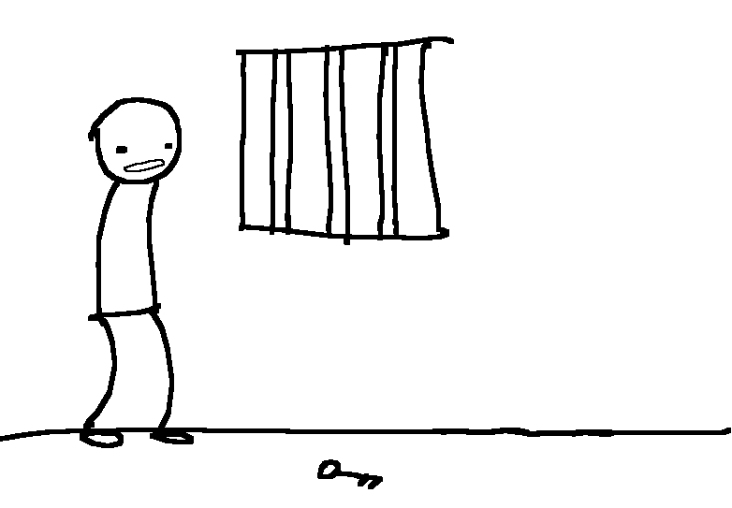
Prison escape game
In this game you find yourself in a prison cell. The aim of the game is to escape from the cell. There is a door, but it is guarded. In the cell are you, the guard, and a small elf sitting in the corner.

Here is the code for the game. Type this in and run it to play the game.

puts "You are in prison. An elf sits in the corner"
puts "To escape you have to get past the guard"
puts "Do you want to fight him? y is yes"
fight = gets.chomp
if fight == "y"
puts "The guard is strong and wins. Game over!"
else
puts "You talk to the elf who offers you a mars bar."
puts "Do you eat it or give it to the guard? e or g"
action = gets.chomp
if action == "e"
puts "Tasty, but you are still in prison. Game over!"
else
puts "You give the guard the mars bar and escape"
puts "while he is eating it. You win!"
end
end
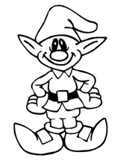
Do you see the way we have an if inside an else here? After you wisely decide not fight, Ruby starts running the stuff between the else and the end, which includes the question about the mars bar, then another if.

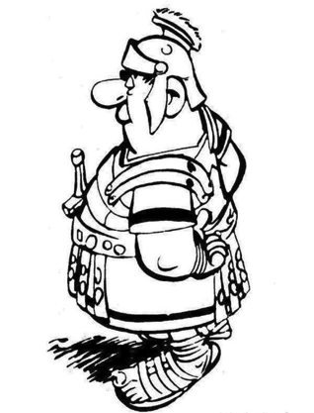
Challenge – Extend the prison game

At the moment if you eat the mars bar you lose. Change the game so when you eat the mars bar the elf then offers you a snickers, which you can either eat of give to the guard. If you eat it you lose, if you give it to the guard you win.

Change the game again so you can only win if you give the guard the snickers. He doesn’t like mars bars, so if you give him the mars he gets angry and locks you to the bed!
Think up more bits to the prison game. Ask one of the other kids to play and see if they can win.

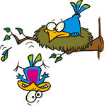
The dangers of messy nesting
So now we have ifs inside ifs inside elses it can all get very confusing. To make it less confusing it’s best if you line things up with spaces. If you have an if, elsifs, an else and an end, try to line them all up. Move the code between in a couple of spaces. It’s boring, but it will make your code easier to understand and you will make less mistakes.

If you don’t line it all up nicely the code will still work, but anyone looking at it will be scratching his or her head. To convince you I will write the prison game again without lining it up properly so you can see how confusing it looks.

puts "You are in prison. An elf sits in the corner"
puts "To escape you have to get past the guard"
puts "Do you want to fight him? y is yes"
fight = gets.chomp
if fight == "y"
puts "The guard is strong and wins. Game over!"
else
puts "You talk to the elf who offers you a mars bar."
puts "Do you eat it, or give it to the guard? e or g"
action = gets.chomp
if action == "e"
puts "Tasty, but you are still in prison. Game over!"
else
puts "You give the guard the mars bar and escape"
puts "while he is eating it. You win!"
end
end

What a mess!

And that’s it for the Choices topic. The next one will be about looping. We will be writing more games too.

